Date:08/12/23
A.Y 2023-24(Odd Sem) Report on PSR Activity: Super AI Community Stakeholder Connect
Objective:
The objective of Super AI Community Stakeholder Connect is to build students’ knowledge, skill and strengthen the domain by inclusion of Industry/ Academia /Alumni expert sessions/Peers Learning sessions, competitions, exhibitions and collaborative research activities.

Following activities are done during Academic Year 2023-24 Odd Semester:

Activity 1: Peer to Peer learning workshop
Date: 20th July, 2023.
Time: 10:00 am to 4:00 pm

Participants: ST, TT and BT students

Objectives:

Enhance participant skills in Mathematics & Python fundamentals, Hands-on ML model making, and Business Analytics tools.

Facilitate peer-to-peer learning for practical application of AI concepts.

Provide a collaborative platform for participants to share knowledge and experiences.

Description:

Super AI Stakeholder Connect's workshop covers Mathematics & Python basics, Hands-on ML model creation, and Business Analytics tools. It fosters practical learning through real-world examples and encourages collaboration among participants for effective knowledge exchange. The interactive sessions aim to equip participants with essential skills in AI and ML.

Participation Analysis:
Sr. No. | Class | No. of Students
1 | ST | 45
2 | TT | 46
3 | BT | 16
Total: |  | 107

Activity Photo:
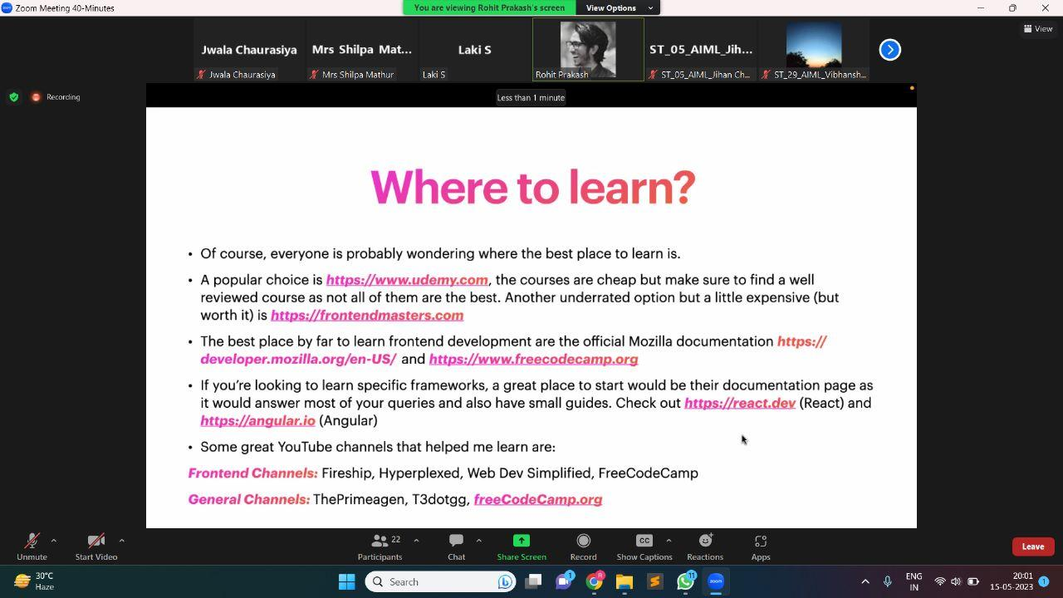

Feedback Analysis:

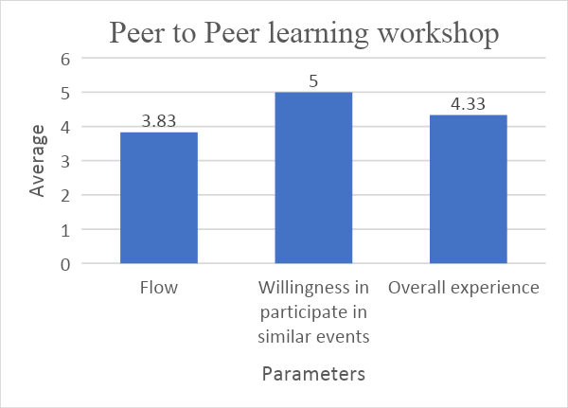
Outcome:
Participants will gain a solid understanding of Mathematics & Python fundamentals, acquire practical skills in building machine learning models. Participants will be proficient in using business analytics tools for data analysis and decision-making.
PO Attained: PO1,PO2,PO3,PO4,PO5
Activity 2: Guidance for Placements and Higher studies
Date: 24th August, 2023.
Time: 3:30pm to 4:30pm

Participants: ST and TT students

Objectives:
- To Gain insights into successful placement strategies from Fourth-Year students who secured positions at Oracle.
- Receive a roadmap for navigating the placement process, encompassing both corporate and startup environments.

Foster a sense of community engagement by encouraging active participation in the placement guidance session.

Description:

Super AI Stakeholder Connect is organizing a placement guidance session featuring accomplished Fourth-Year students who have secured coveted positions at Oracle. The session will be an opportunity for attendees to glean firsthand insights, strategies, and experiences that contributed to their successful placements. The speakers will provide a comprehensive roadmap for navigating the placement process, offering guidance on interviews and exploration of opportunities in both corporate and startup realms. The event emphasizes community engagement, urging all participants to attend and actively contribute to the collaborative learning environment.

Participation Analysis:

Sr. No. | Class | No. of Students
1 | ST | 22
2 | TT | 27
Total: |  | 49

Activity Photo:

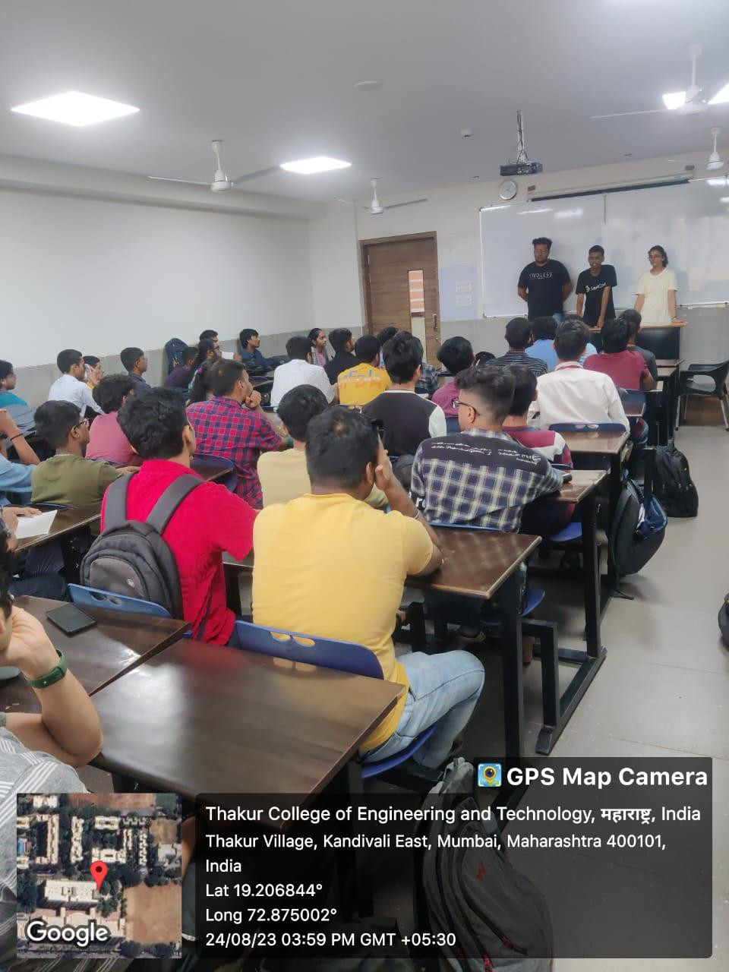

Feedback Analysis:

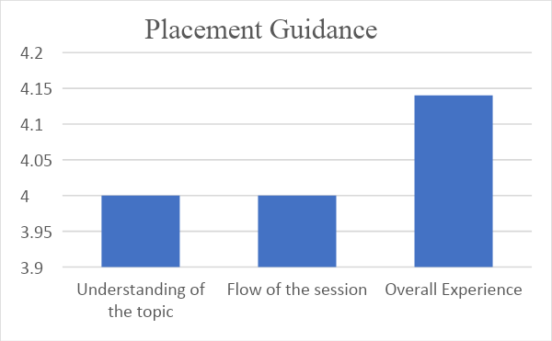

Outcome:
- Attendees will be informed about successful placement strategies and experiences.
- Participants will leave with a clear roadmap for navigating the placement process.
- The event will contribute to a sense of community engagement and collaboration.
PO Attained: PO6, PO8, PO10,PO12

Activity 3: Expert Lecture on "Tensorflow with MLOPs”
Date: 13th and 14th September, 2023.

Time: 2.30 pm onwards

Participants: ST,TT and BT Students

Objectives:

Equip students with practical knowledge of Machine Learning Operations (MLOps), focusing on the deployment phase after building machine learning models.

Provide a hands-on learning experience to enhance participants' understanding of MLOps concepts.

Offer flexibility by allowing students to use their laptops or providing access to lab PCs for the session.

Description:
Super AI Community Stakeholder Connect is organizing an expert learning session on MLOps, concentrating on the deployment phase following the creation of machine learning models. The session aims to impart practical knowledge and skills in MLOps, covering topics crucial for efficiently deploying and managing machine learning solutions.
This will be a hands-on session, allowing participants to actively engage with the material. Students have the option to bring their laptops, providing a personalized learning experience, or utilize the lab PCs. The session will cover key aspects of MLOps, ensuring participants gain proficiency in deploying and managing machine learning models in real-world scenarios.

Participation Analysis:

Sr. No. | Class | No. of Students
1 | ST | 14
2 | TT | 16
3 | BT | 5
Total : |  | 35

Activity Photo:
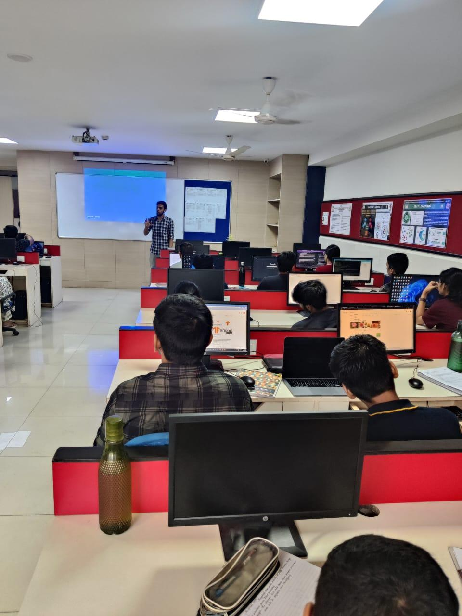

Feedback Analysis:

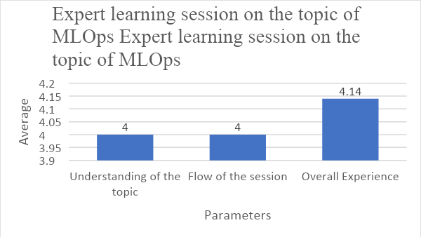

Outcome:

Participants will gain practical knowledge and skills in MLOps, specifically in the deployment phase. The hands-on session will enable participants to apply MLOps concepts in a practical setting. Participants can choose to use their laptops, promoting a personalized and flexible learning environment.

PO Attained: PO1,PO2,PO3,PO4,PO9,PO10,PO12

Activity 4: Workshop on Explainable AI with Industry Case Studies

Date: 1st & 2nd October, 2023 (Sunday & Monday)

Time: 11:00 AM - 3:00 PM

Participants: ST,TT and BT Students

Objectives:

Foster holistic student development by providing practical skills and insights essential for academic and professional growth.

Enable participants to acquire hands-on experience and actionable knowledge during the two-day workshop.

Empower students with valuable insights to navigate their academic and professional journeys effectively.

Description:

Super AI Community Stakeholder Connect is excited to announce a two-day hands-on workshop dedicated to Holistic Student Development. The workshop, conducted by the SuperAI Connect Club, is meticulously designed to provide participants with practical skills and insights crucial for their academic and professional journey.

During the workshop, participants will engage in valuable sessions aimed at enhancing various aspects of their development. The emphasis will be on hands-on learning, allowing attendees to acquire practical skills that can be directly applied to their academic pursuits and future careers. The SuperAI Connect Club is committed to creating an empowering environment, encouraging participants to take a significant step towards holistic development.

Participation Analysis:

Sr. No. | Class | No. of Students
1 | ST | 12
2 | TT | 30
3 | BT | 05
Total : |  | 47

Activity Photo:

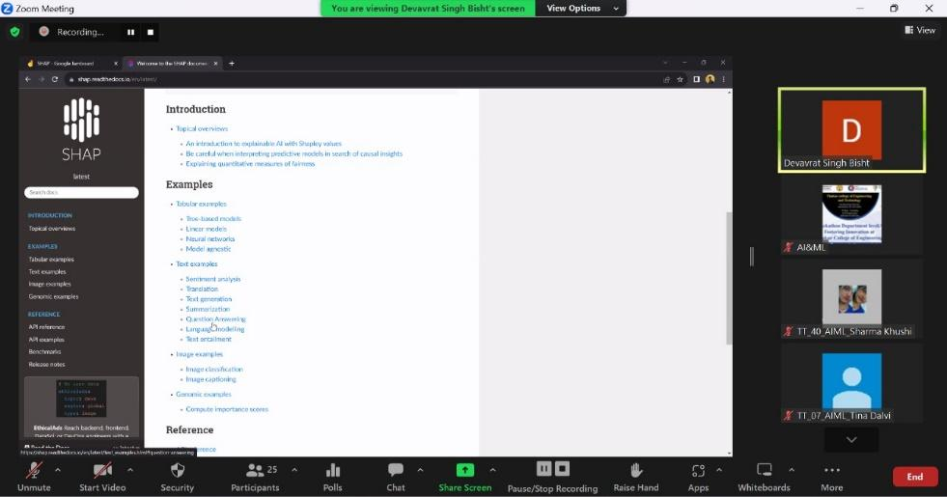

Feedback Analysis:

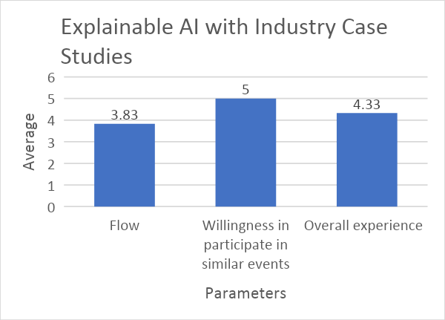

Outcome:
Participants will develop a holistic skill set encompassing both academic and professional aspects. Attendees will gain actionable knowledge that can be immediately applied in their academic and professional endeavours. The workshop aims to empower participants with insights and skills to navigate their educational and professional journeys more effectively.
PO Attained: PO1,PO2,PO3,PO4,PO9,PO10,PO12
Activity 5: Offline Coding Competition on HackerRank

Date - 13th October, 2023

Time - 2:30 pm onwards

Participants: ST, TT,BT Students

Objectives:

Provide participants with an opportunity to enhance their coding and problem-solving skills.

Foster a spirit of healthy competition to motivate participants to excel in coding challenges.

Promote community engagement and collaboration through a coding competition.

Description:

Super AI Community Stakeholder Connect is excited to host a Coding Competition, offering participants a platform to enhance their coding and problem-solving skills. The competition is designed to challenge participants with a series of coding problems that span various difficulty levels, providing a comprehensive learning experience.The competition offers a prize pool of Rs.2500, distributed among the top two winners: 1st place receives Rs.1500, 2nd place receives Rs.1000.

Participation Analysis:

Sr. No. | Class | No. of Students
1 | ST | 06
2 | TT | 15
3 | BT | 09
Total : |  | 30

Activity Photo:
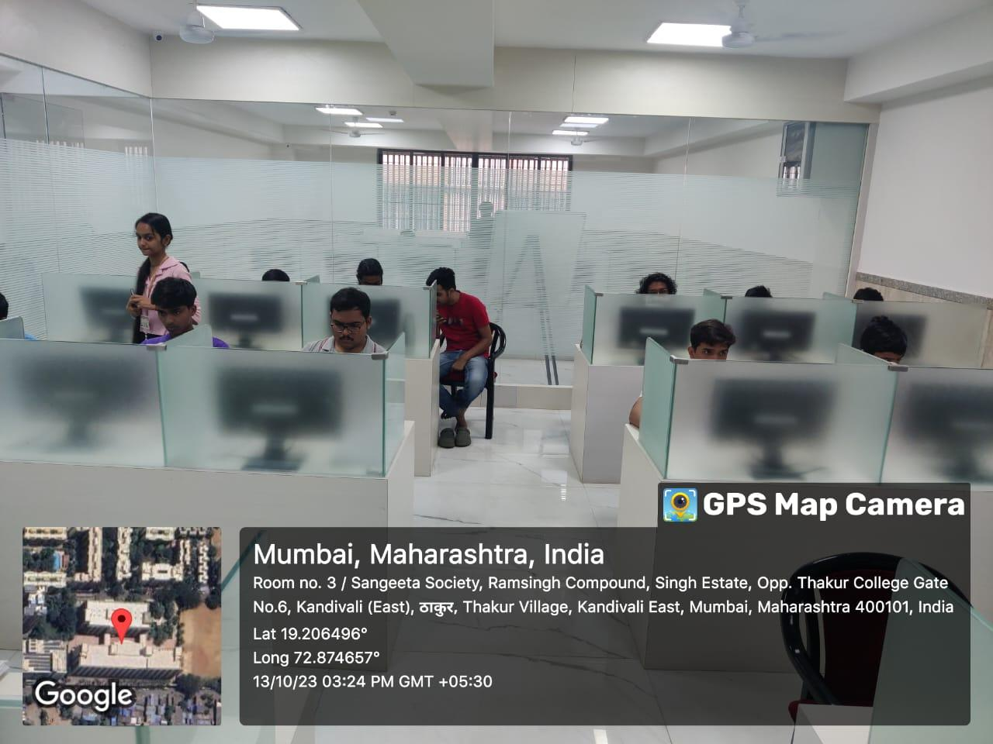

Feedback Analysis:

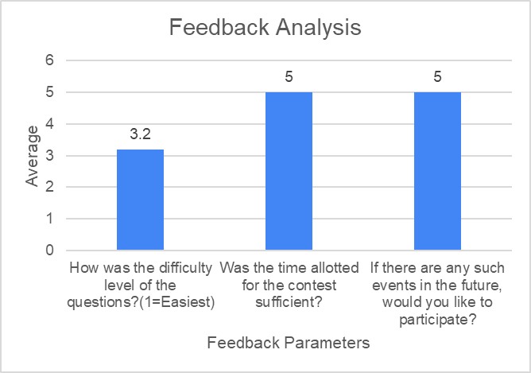

Outcome:
Students were able to enhance their problem-solving abilities and cognitive reasoning skills through active participation in the Quiz competition.
PO Attained:PO1,PO2,PO3,PO4,PO5,PO8,PO9
Activity 6: Project Competition

Date: 30th October 2023

Time: 4.30 pm onwards

Participants: ST,TT and BT Students

Objectives:

Innovative Project Development: Encourage ST, TT, and BT students in the AI&ML Department to showcase their innovative project ideas.

Foster teamwork by allowing students to participate in teams of 1-4 members.

Emphasize the practical application of AI and ML concepts through project implementation.

Description:

Super AI Community Stakeholder Connect is hosting a Project Competition open to all ST, TT, and BT students in the AI&ML Department. The competition invites students to form teams of 1-4 members and submit their project ideas using the provided PPT template.

In Phase 1, students are required to submit their project ideas online by the deadline of 23rd October 2023. The selected teams will proceed to Phase 2, an offline presentation scheduled for 30th October 2023. During Phase 2, ST students will present their project ideas, TT students will showcase at least 30% implementation, and BT students are expected to demonstrate full implementation.

The competition offers a prize pool of Rs.5000, distributed among the top three winners: 1st place receives Rs.2500, 2nd place receives Rs.1500, and 3rd place receives Rs.1000.

Participation Analysis:

Sr. No. | Class | No. of Students
1 | ST | 1
2 | TT | 10
3 | BT | 1
Total : |  | 12

Activity Photo:

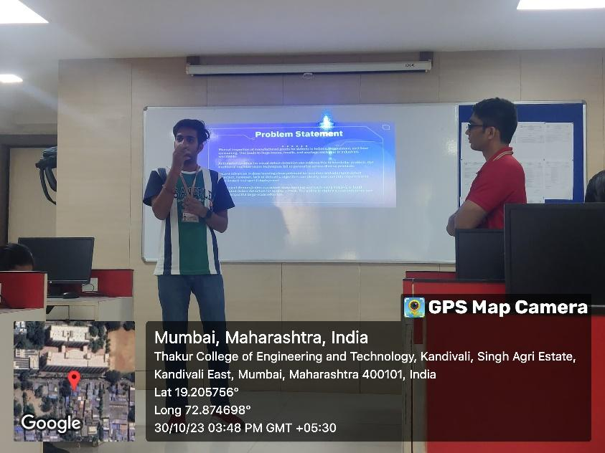

Feedback Analysis:

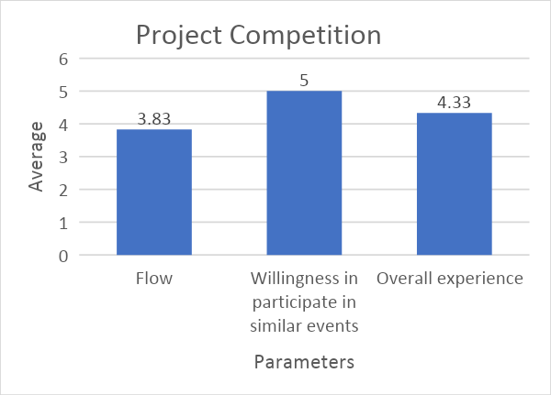

Outcome:
Participants will showcase innovative project ideas in the field of AI&ML. The competition promotes teamwork as students collaborate in teams of 1-4 members. Students will gain hands-on experience by implementing their project ideas, aligning with their respective categories.
PO Attained: PO1,PO2,PO3,PO4,PO5,PO7,PO8,PO9,PO10,PO12

Prepared By
Mrs Shilpa Mathur Dr.Megharani Patil
Faculty Coordinator Convener
Assistant Professor AI&ML HOD AI&ML

